Lab Manual

Lab 1 CUPS Quantum Mechanics Simulation ………….2
Lab 2 CUPS Semiconductor Physics Simulation………...9
Lab 3 Electron Diffraction ……………………………….16
Lab 4 Hall Effect…………………………………………..24
Lab 5 Measurement of the Band Gap for Germanium....39
PHYS2170 Quantum Mechanics and Semiconductor Physics

Laboratory 1: Quantum Mechanics simulation
Assessable  items for this  Laboratory | Comments | Maximum Marks:
Preparation | Your preparation must be done BEFORE the laboratory session starts.  Preparation work is to be completed in your workbook.  Your Preparation must be signed by your demonstrator at the beginning of the laboratory. | 5
Workbook | Your Workbook must include :  Date you did the experiment :  Name of experiment :  Your lab work including :  Theoretical concept, formula and the laboratory goals;  Record of all your experimental notes, details, observations, collected data;  Essential diagrams, graphs, calculations;  All graphs and tables must be label,  Conclusion: clear experimental result  All inserts must be glued, stapled or sticky taped into the appropriate places of your workbook  Your workbook must be signed by your demonstrator before leaving the laboratory. | 10
Report | The final report should contain an abstract, introduction, results, discussion and conclusion. The introduction for this particular lab should at least be about Schroedinger equation and what properties that it’s solutions must generally have (all good quantum mechanics textbooks can help you with this). You may also want to write about what an ‘observable’ is in quantum mechanics and give examples. The results and discussion sections can be combined and should contain answers to the questions in bold in these notes as well as a discussion on the importance and implications of each phenomenon you investigate. A procedure is not required in this lab as the entire lab is computer based.  The report must also be self-contained and written in your own words (do not refer to materials that are in your workbook, and do not reproduce materials from this handout except for the figures). | 10

Lab 1: QUANTUM MECHANICS SIMULATION

Aim

To work through a number of simulations to:

- Observe how wavepackets evolve in time.
- Explore normalisation, calculation of expectation values and time development of wavefunction in a square well potential.
3. Calculate solutions to the Schrödinger equation for well and barrier potentials.

References

- “Semiconductor Physics and Devices Basic Principles”, Donald A Neamen, Chapter 2.
- Lecture notes

Structure of Laboratory Exercise

This lab is a computer lab. Each of the individual sections has instructions, hints as to what you should be looking at, and questions for you to answer. Use your workbook to record what each investigation shows you, and then expand and discuss in your report. The first section (1.1) has example answers to show you what sort of things you should be thinking about during the lab.

Preparation

- Perform the following calculations in your laboratory notebook.
1.1 Calculate the energies in eV of the first 6 allowed states for an electron in an infinite square well of width L = 0.2 nm. (Partial answer E1=9.4 eV, E2= 37.6 eV ...)
  - Write down expressions for ψ_{n}(x) for n = 1….to 6.
1.3 Discuss how the energies of the first 6 allowed states might change from those in part (1.1) above if the well was not infinite but finite with a depth of 300 eV.
- From the solution of the time independent Schrödinger equation (TISE) given in the lecture notes, write down an expression for the wavefunction of a 0.5 eV electron moving from the left (x<0) and interacting with a 1eV step potential at x=0. Calculate k and β. Hence calculate the wavelength of the sinusoidal solution ψ(x) for x<0.
- How does the wavelength change if the electron energy is reduced to 0.25eV? Describe how the wavefunction would change for x<0 for E=0.25 eV. How does β change if the electron energy is increased to 0.9 eV? Describe how the wavefunction would change for x>0 in this case.

1. Quantum Mechanical Time Development

Where have ‘particles’ gone in quantum mechanics? Classical particles are perfectly localised - at each point in time, the particle is at one point in space. The Schroedinger equation, however, is apparently a wave equation, giving solutions that have a value at each point in space at any given time. We will see here, however, that the idea of a localised particle is still present in quantum mechanics, but with some subtle differences.

The time dependent Schröedinger equation is being solved for ψ(x,t) for a potential V=V(x) so the solution should look like
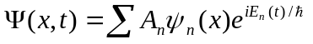
where ψ_{n}(x) is the solution of the time independent Schröedinger equation. If we want to construct a quantum ‘particle’, we just need to take an appropriate sum of solutions to the Schröedinger equation.

Flat Potential Distribution

(i) Select "Quantum Mechanical Time Development", "Potential", "Flat", “0eV”, “Display", "Plot How", "Probability Density”, “Display”, “Plot What”, “Position Space Wavefunction”, “Momentum Space Wavefunction”, “Display”, "Show Mean Values”, “Display”, “Show Uncertainties”
- Observe that initially Δx = 0.2 nm, Δp = 2.5 ħ, ΔpΔx = ħ/2 for the Gaussian wavefunction. Does this agree with the Heisenberg Uncertainty Principle? Comment.

It does agree with the Heisenberg Uncertainty Principle, because ΔpΔx ≥ ħ/2 as required. A Gaussian wavepacket is the ‘minimum uncertainty wavepacket’, the wavepacket with the best possible localisation in both position and momentum.

- Change the wavefunction to "Lorentzian" with default values. Write down the value of ΔpΔx. Does this agree with the Heisenberg Uncertainty Principle?

Again, the Lorentzian wavepacket agrees with the HUP, because this time ΔpΔx > ħ/2.

- Change back to the Gaussian wavefunction with default settings and select "Run" and F3 to step forward in time. Observe that the wavefunction spreads out and moves to the right. Explain (a) why the wavefunction moves to the right and (b) why it spreads out in time. (Hint – observe the momentum plot). To rerun the simulation enter “Reset”, “Reset this run”, “Run”.

The wavefunction’s momentum distribution mostly consists of positive momentum
components, so the combined wavefunction appears to also ‘mostly’ have positive momentum.
However, in answer to (b), since not all the momentum components have the same value,
some will move ‘faster’ than others, resulting in the spreading out you see when the packet
moves forwards in time.

- Write down values for ΔpΔx at times of 1fs and 2fs after starting the run. Note that 1fs = 10^{–15} s.
- Reset to the same run. Halve the position uncertainty to 0.1nm in the "Wavefunction", "Gaussian", parameters section. Write down the initial values for Δx, Δp and ΔpΔx. Quantitatively how does the momentum distribution change? Now hit "Run". Record ΔpΔx, 2fs after starting. Does the position distribution change any differently with time compared to (v) above? Discuss.

By halving the position uncertainty for a Gaussian wavepacket, you must necessarily double the uncertainty in momentum, so the momentum distribution gets wider by a factor of two. Now, since the momentum distribution is wider, the off-peak momentum components contribute more to the wavepacket, and we see that as time passes, the wavepacket spreads out much faster.

Suggested Discussion Item for Final Report.

Discuss how quantum particles are seen to behave differently than classical particles in this simulation, with reference to the Heisenberg Uncertainty Principle. Based on these simulations, do you think quantum particles are distinguishable or indistinguishable?

2. One Dimensional Bound State Problems

Now we will look at the allowed stationary states of bound systems. These bound states are the solutions of the time-independent Schroedinger equation that have distinct energies.

Finite Square Well

- Select the “1D bound state problems” option.
- Select “Parts”, ”Part 1”, “Potential”, “Square Well”, “Parameters”, ”Vary Well parameters”, “300 eV,0.2 nm”, “Method”, ”Try energy with mouse”.
- Move the cursor to the centre of the well at about 150 eV and click. The program solves Schroedinger’s equation for the energy and displays the solution.
Is the wavefunction shown a physically allowable wavefunction? What limit should the wavefunction approach as x → ∞ if it is physically allowable?
- Find the approximate values (to within 10 eV) of binding energy corresponding to the 6 allowed solutions. Write down the approximate energies.
- Now observe the exact values of binding energy by selecting “Spectrum”, ”Find Eigenvalues”. To find the numerical values of binding energy, select “Spectrum”, ”See Wavefunctions” and then select each solution (1-6) in turn. Write down the six allowed energies relative to a potential of 0eV at the bottom of the well. Note that in the simulation, the potential energy at the bottom of the well is –300 eV and not 0 eV as is the case in the lecture notes and the text.
- Compare the energies to the values obtained in the preparation and comment.
- Clear the screen and replot solutions 1, 4 and 6. Print these solutions and place them in your workbook. Discuss how the wavefunctions compare to the solutions for the infinite well in your textbook or lecture notes
- Select “Spectrum”, “See Wavefunctions and Probabilities” and display solutions 1,4 and 6. Discuss where the particle is most likely to be in the three cases. Discuss whether the particle can ever be found to be outside the well.

3. Normalization and Expectation Values in a finite square well

Quantum mechanics says that whenever we make a measurement of an observable A, it’s value will be an eigenvalue of the operator A. We might wonder though, what would we expect to get if we make a very large number of measurements? The answer is given statistically by the expectation value of A, denoted <A> and given by ∫ ψ*Aψ dx.

Expectation integrals and normalisation integrals will be computed in this section.

- Calculate the energy levels for the finite square well (300 eV, 0.2 nm) as in the first laboratory exercise. Then select “Parts”, “Part2”, “ψ1”, “n=1”, “operator”, ”1”, ”ψ2”, ”n=1”. Two identical wavefunctions (both for n=1) will be displayed. Press “integrate”. This will perform the integral where the operator A in this case is 1, i.e the integral
∫ ψ₁* 1 ψ₁ dx
where ψ₁ is the solution for the finite square well for n=1 and the integration is over all allowed values of x. Write down the value of the integral and comment.

- Now repeat the above procedure with “operator”, “x” and integrate. Write down the value of the integral. Comment on what this value says about the mean position of the particle in the well in the n=1 state. Try this integral for other states n=2, 3.. (i.e. “ψ1”, “n=2”, “operator”, “x”, “ψ2”, “n=2”, “integrate”, and so on). Comment on why all the values are the same.

- Determine, using the cups software, the expectation values of the total energy <E> and potential energy <V> for n=1. Write down the values (relative to 0eV at the bottom of the well) and comment on how the values.

- Hence write down the value of the kinetic energy, K, based on (iii).

- The kinetic energy can be written as <p²/2m>. Work out how to calculate this expectation value by finding the expectation value of the p² operator. Using the value of <p²>, calculate <p²/2m> and compare to the expectation value of the kinetic energy operator in (iv). Note that the units of energy in the program are eV and the units of distance are nm. So calculating ∫ ψ₁* x ψ₁ dx will give an answer in nm and calculating
∫ ψ₁* (∂² / ∂x² ) ψ₁ dx will give an answer in nm⁻². All integrals should be converted to SI units before being used in calculations.

Suggested Discussion item for final report

Discuss how wavefunctions are normalised and how expectation values are calculated. Explain the physical significance of the expectation values you calculated here.

- Stationary States in One Dimension

  - Step potential

(i) Select the "Stationary Scattering States in ID" option.
- First simulate a 0.5 eV particle hitting a 1 eV step. Select "Potential", "step", "1 eV, 1, 0 nm, 2 nm", “Parameters", "Direct integration, 100", "Compute", "Wavefunction, 0.5 eV, -2 nm, 2 nm, -1.5, 1.5"
- The plot shows the magnitude of the wavefunction and the colour shows the phase of the wavefunction. So the light blue section of the wavefunction is 180 degrees out of phase with the mauve part (notice that blue and mauve are on opposite sides of the circle). So the blue part represents the negative part of the wavefunction and the mauve the positive part of the wavefunction.
- The shape of the wavefunction is related to whether E>V or vice-versa. Discuss why the shape of the wavefunction is sinusoidal for x<0 but an exponential decay for x>0.
- Estimate the wavelength of the sinusoid for x < 0 and compare to the value calculated in the preparation. Record this value.
- Select “Compute”, “Wavefunction, 0.25 eV” to now solve for a 0.25 eV electron interacting with the step. Again estimate the wavelength of the sinusoid for x < 0 and compare to the value calculated in the preparation. Record this value.

Suggested Discussion Item for Final Report

Discuss the general shape of the solution for a particle of energy E interacting with a step function of height V. How does the solution depend on E and V? Does the solution agree with what might be expected classically?

  - Square Barrier Potential

(i) Select "Potential", "square barrier”, "1 eV, -0.5 nm, 0.5 nm", "Compute wavefunction", "0.5 eV, -2.8 nm, 2.8 nm, -1.5, 1.5” to simulate a 0.5 eV particle interacting with a 1 eV high barrier 1 nm wide.
(ii) Determine R and T. Compare R, T with values calculated from the textbook or lecture notes.
(iii) How can the potential barrier be changed to increase transmission? Alter the potential barrier by selecting new parameters. Record the new parameters and new values of R,T.
(iv) How qualitatively does transmission change with energy? Check by selecting "Potential", “Square Barrier”, "1 eV, -0.5 nm, 0.5 nm", "Compute", “trans and refl probabilities", “0.5 eV, 5.5 eV,0.01 eV". Print out the curve obtained and enter it in your workbook.

Suggested Discussion Item for Final Report

Discuss how the transmission of particles through thin barriers changes with particle energy. Approximately, how thin must barriers be to allow significant tunnelling of electrons in typical semiconductors?

Final Report for QM simulation

The final report should contain an abstract, introduction, results, discussion and conclusion. The introduction for this particular lab should at least be about Schroedinger equation and what properties it’s solutions must generally have (all good quantum mechanics textbooks can help you with this). You may also want to write about what an ‘observable’ is in quantum mechanics and give examples. The results and discussion sections can be combined and should contain answers to the questions in bold in these notes as well as a discussion on the importance and implications of each phenomenon you investigate. A procedure is not required in this lab as the entire lab is computer based.

Note: You don’t need to cover all four parts of simulations in your report. However, it is important to write your introduction, results and discussion, and conclusions in a coherent way.

Specific Safety Precautions – Quantum Mechanics Simulation Experiment

Below is a list of risks and controls specific to this experiment. Please read it carefully before commencing the experiment and refer to it as necessary during the course of the experiment.
Further details can be found in the Standard Operating Procedure and Risk Assessment document for this experiment, which is available in the laboratory.

Risk | Control
RSI from using computers | Adjust workstation furniture to allow for comfortable use of computer.  Minimise time spent in front of computer.
Eye strain from CRT screen | Arrange workstations to keep CRT as far away from the user as practicable.  Minimise time spent in front of computer.
Exposure to electromagnetic field from CRT monitor | Minimise time spent in front of computer.
Exposure to dangerous voltages from faulty equipment. | Do not use faulty equipment.  Report faulty equipment to demonstrator immediately.  Check all power cords for visible deterioration prior to use.
Trip hazard due to obstructions in walkways. | Keep bags under benches to avoid obstructions.

PHYS2170 Quantum Mechanics and Semiconductor Physics

Laboratory 2 : Semiconductor simulation
Assessable  items for this  Laboratory | Comments | Maximum Marks:
Preparation | Your preparation must be done BEFORE the laboratory session starts.  Preparation work is to be completed in your workbook.  Your Preparation must be signed by your demonstrator at the beginning of the laboratory. | 5
Workbook | Your Workbook must include :  Date you did the experiment :  Name of experiment :  Your lab work including :  Theoretical concept, formula and the laboratory goals;  Record of all your experimental notes, details, observations, collected data;  Essential diagrams, graphs, calculations;  All graphs and tables must be label,  Conclusion: clear experimental result  All inserts must be glued, stapled or sticky taped into the appropriate places of your workbook  Your workbook must be signed by your demonstrator before leaving the laboratory. | 10
Report | The final report should contain an abstract, introduction, results, discussion and conclusion. The results and discussion sections can be combined and should contain answers to the questions in bold in these notes as well as a discussion on the importance and implications of each phenomenon you investigate. An experimental procedure is not required in this lab as the entire lab is computer based.  The report must also be self-contained and written in your own words (do not refer to materials that are in your workbook, and do not reproduce materials from this handout except for the figures). | 10

Lab 2: PHYSICS OF SEMICONDUCTORS
Aims
- To determine the allowed energies and wavefunctions for two finite wells, and investigate the changes that occur when the separation of two finite wells is reduced.
- To investigate changes in atomic energy levels arising from the periodicity of crystalline structures, and understand how these lead to the formation of allowed energy bands, and forbidden bands (band gaps).
References
1. Chapter 3, Neamen. D.A., "Semiconductor Physics and Devices: Basic Principles", McGraw-Hill Higher Education.
Structure of Laboratory Exercise

This lab is a computer lab. Each of the individual sections has instructions, hints as to what you should be looking at, and questions for you to answer. Use your workbook to record what each investigation shows you, and then expand and discuss in your report.

The Kronig-Penney Model

An insight into the behaviour of electrons in a crystal lattice is provided by the Kronig-Penney model. In this model, the potential energy of an electron moving in a periodic lattice is approximated by a periodic array of square wells as shown in figure 1. This greatly simplifies the solution of Schrodinger’s equation, from which the possible energies of the electron in the periodic potential field are determined.
The Kronig-Penney model is somewhat crude, but its usefulness lies in the fact that the analysis illustrates the formation of energy bands and band gaps in a relatively simple way.
The solutions, ψ(x), of Schrodinger’s equation for the periodic potential are Bloch functions of the form e^{ikx}u_{k}(x), where u_{k}(x) is a function which has the same periodicity as the potential field.
ψ(x) = e^{ikx}u_{k}(x) (1)
The solution, ψ(x), has the form of a plane wave, e^{ikx}, modulated by the periodic function, u_{k}(x).
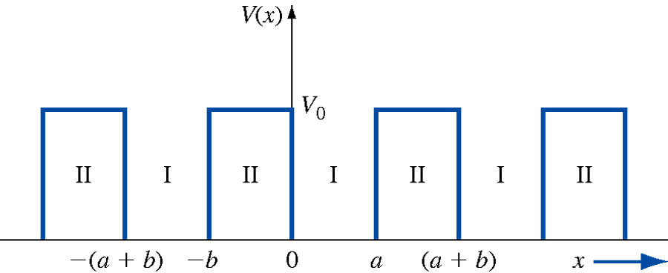

Figure 1. Schematic diagram shows the potential energy of an electron moving in a periodic lattice and the approximation used in the Kronig-Penney model.
The final solution is in the form of the following transcendental equation, which relates the electronic energy E to the wave number k:
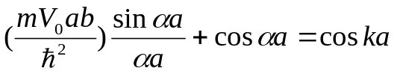
(2)
where α² = 2mE/ħ^2. The parameter, a+b, is the period of the lattice, b is the width of the barrier separating two adjacent potential wells, a is the width of the each potential well and m is the mass of the electron.
Note that the right-hand side of equation 2 must lie between -1 and +1, but the lift-hand side is not restricted to any particular range of values. Consequently, there are only certain ranges of values of the energy, E, for which values of k can be determined. This points to the existence of bands and band gaps.
The boundaries of the allowed energy bands (and the band gaps) can be determined by working out values of the energy, E, for which the left-hand side of equation (2) lies between -1 and +1. This can be done in an Excel spreadsheet.

Preparation (also see in textbook, chapter 3.1)

Using an Excel spreadsheet, or otherwise, plot a graph of the left-hand side of equation (2) against the energy, E, in electron volts (eV) for a periodic array of square wells each of depth 300 eV, width a 0.2 nm, and barrier width 0.2 nm. Use SI units to calculate the value of the left-hand side. (Notes: E is related to α )
- From the shape of the graph determine the allowed energies (in eV) for electrons that are free to move through the lattice.
- How do the allowed energies for the periodic lattice compare with those of a single well for the same well depth and width? Discuss with respect to the first QM lab.
- Two Square Wells
What happens when two square wells are present? If the wells are infinitely deep, then nothing special happens because the wavefunctions must be zero at the well edges and therefore no tunnelling occurs. However, if the wells are finite and close together, then we can’t consider the two wells to be separate - they form one ‘system’ with unique properties. In this simulation, the wavefunctions and allowed energies for two finite square wells are investigated. In particular, the effects of changing the well separation on the allowed energies are studied in terms of the symmetries of the wavefunctions.
In this simulation, the allowed energies for a double well are determined for several well separations. The objective is to better understand the changes that occur in the energy levels.
- Select “One Dimensional Bound State Problems”, “Parts; Part 1: Finding Eigenvalues”, “Potential; Double Square Well”, “Parameters; Vary Well Parameters, 300, 0, 0.2, 0.1”. This sets up two square wells each of depth 300 eV and width 0.05 nm, separated by 0.1 nm.
- Select "Spectrum; Find Eigenvalues" to display the allowed energy levels for the double square well.
- Determine the binding energy by selecting "Spectrum; See Wavefunctions", and entering the numbers 1, 2, 3 and 4 in succession. Write down the allowed energies relative to 0 eV at the bottom of the well.
Note that there are two ‘groups’ of energies separated by a large energy gap.
- For a single well of depth 300 eV and width 0.05 nm, the allowed energies are 70.3eV and 248.0 eV for n=1 and 2 respectively. How are the allowed energies for the double well related to those of the single well? Discuss.
- Select "Parameters; Vary Well Parameters, 300, 0, 0.15, 0.05" to reduce the separation of the wells from 0.1 nm to 0.05 nm.
- Determine the allowed energies and display the wavefunctions as in (iii) above. Write down the allowed energies relative to 0eV at the bottom of the well.
- Repeat the procedures (v) and (vi) for well separations of 0.01nm (enter 300, 0, 0.1, 0.01) and 0 nm (enter 300, 0, 0.1, 0.0; n=1, 2 and 3 only).
- Tabulate the well separations and the corresponding energies (relative to 0 eV at the bottom of the wells) for the two bands of energy levels. Plot the energies against the separation of the two wells on the same graph.
- On the same graph, draw horizontal lines at the energies of the first two levels for a single finite well of the same depth and width as those of a single well in the lattice (n = 1, E = 70.3 eV; n = 2, E = 248.0 eV).
- What are the effects of reducing the separation of the two wells (i.e. increasing the interaction of the single well wavefunctions) on the allowed energies? Discuss.

- Regular Lattice of Wells

So far, the simulations have been confined to investigations of electron energies for single and double wells. In this exercise the number of wells in a lattice is increased (simulating an increase in the number of atoms in the lattice), and the resulting effects on the allowed energies are studied. The aim is to simulate the motion of an electron in a periodic lattice and determine the allowed energies.
- From the main menu, select "Electron States in One Dimensional Lattice", "Wells; Number of wells, 4", "Wells; Shape of Each Well, Square", "Well Parameters, 300, 0.05", "Lattice; Regular Lattice". This sets up a lattice of 4 square wells each of depth 300 eV and width 0.05 nm. The separation of adjacent wells is 0.05 nm. The depth, width and separation of the wells are the same as those used in the Kronig-Penney model (refer to the preparation in section (VI).
(ii) Select "Spectrum; Find Eigenvalues" to display the allowed energies. How do the energies compare with those of the single and double wells? Discuss.
- Display the wavefunctions for the states which are at the boundaries of the groups of states (in this case, n=1,4 and n=5,8) and write down the allowed energies relative to 0 eV at the bottom of the well. Do not print the wavefunctions. Printouts are attached to this hand-out (make sure that each wavefunction is identified and clearly marked).
What conclusions can be drawn from inspections of the following:
- the number of states in each ‘group’
- the shapes of the wavefunctions in each group. In particular, are there any similarities between these wavefunctions and those of the single well (the latter is attached to this hand-out)
(iv) Repeat (i), (ii) and (iii), but for 6 and 12 wells (in (i) make sure that the well width is 0.05 nm). For 6 wells, n=1, 6 and n=7, 12. For twelve wells, n=1, 12 and n=13, 24.
- Compare the number of states in each ‘group’ of states for 1, 4, 6 and 12 wells. Are there any obvious trends? Discuss.
- For the two groups of states measured in (iii) and (iv), how do the energies of the states which are at the boundaries compare with the first two allowed energies for a single well of depth 300 eV and width 0.05 nm (n = 1, E = 70.3 eV; n = 2, E = 248.0 eV)? Discuss.
- Compare the energies at the boundaries of the two groups of states for the lattice of 12 wells with those determined in the preparation. What are the conclusions that can be drawn? Discuss.
- How do the above observations explain the formation of energy bands in solids (remember that the latter consist of a large number of atoms)? Discuss.

- Irregular Lattice of Wells

The doping of a periodic lattice may be simulated (roughly) by introducing an irregular potential in the lattice. This may be done by changing the width or the depth of a well, or both.
  - Select "Wells; Number of wells, 12", "Wells; Shape of Each Well, Square", "Well Parameters, 300, 0.05", "Lattice; Adjust Parameters". Change the depth of lattice 6 from 300 eV to 250 eV. This sets up a lattice of 12 square wells each of depth 300 eV and width 0.05 nm, except for well 6 which is shallower (250 eV in depth). The separation of adjacent wells is 0.05 nm.
  - Select "Spectrum; Find Eigenvalues" to display the allowed energies. How do the distributions of energies in the two groups of states compare with those of the regular lattice of 12 wells? In particular, what happens to the states for which n=12 and 24 respectively? Discuss.
  - Select “Wells; Well Parameters, 300, 0.05”, “Lattice; Adjust Parameters”. Change the width of well 6 to 0.04 nm. This sets up a lattice of 12 wells each of depth 300 eV and width 0.05 nm, except for well 6 which is narrower (0.04 nm wide)
  - Select "Spectrum; Find Eigenvalues" to display the allowed energies. How do the distributions of energies in the two groups of states compare with those of the regular lattice of 12 wells and the irregular lattice in (i)? In particular, what happens to the state for which n= 12? Discuss.
  - How do the above observations explain changes in the electrical conductivity of semiconductors when they are ‘doped’ with “impurity” atoms? Discuss.

Suggested Items for Discussion in the Final Report

This could include a qualitative discussion of the solution of Schrodinger’s equation for a periodic potential, including the boundary conditions that must be imposed on the possible solutions (without giving the details of the actual solution).
- The Kronig-Penney model and the significance of the results from the preparation.
- The similarities and differences between the shapes of the wavefunctions for multiple wells and those of a single well, and how these relate to the Bloch theorem.
- A detailed discussion of changes in allowed energy levels when the separation of two potential wells is reduced.
- Extension of the discussion to the energy distributions for 4, 6 and 12 wells, and the formation of energy bands and band gaps in semiconductors.
- The importance of the energy band theory in understanding the conductivity of semiconductors, including the effects of semiconductor doping.
Discussions of the above items in your report should not be itemised but should be integrated to form the body of the report.

Final Report

The final report should contain an abstract, introduction, results, discussion and conclusion. The results and discussion sections can be combined and should contain answers to the questions in bold in these notes as well as a discussion on the importance and implications of each phenomenon you investigate. An experimental procedure is not required in this lab as the entire lab is computer based.

Specific Safety Precautions – Physics of Semiconductors Experiment

Below is a list of risks and controls specific to this experiment. Please read it carefully before commencing the experiment and refer to it as necessary during the course of the experiment.
Further details can be found in the Standard Operating Procedure and Risk Assessment document for this experiment, which is available in the laboratory.

Risk | Control
Eye strain from CRT screen | Arrange workstations to keep CRT as far away from the user as practicable.
RSI from using computers | Adjust workstation furniture to allow for comfortable use of computer.  Minimise time spent in front of computer.
Exposure to dangerous voltages from faulty equipment. | Do not use faulty equipment.  Report faulty equipment to demonstrator immediately.  Check all power cords for visible deterioration prior to use.
Trip hazard due to obstructions in walkways | Keep bags under benches to avoid obstructions.

Course : PHYS2170 Quantum Mechanics and Semiconductor Physics

Laboratory 3: Electron Diffraction
Assessable  items for this  Laboratory | Comments | Maximum Marks:
Preparation | Your preparation must be done BEFORE the laboratory session starts.  Preparation work is to be completed in your workbook.  Your Preparation must be signed by your demonstrator at the beginning of the laboratory. | 5
Workbook | Your Workbook must include :  Date you did the experiment :  Name of experiment :  Your lab work including :  Theoretical concept, formula and the laboratory goals;  Sketch/diagram/photo of lab apparatus, equipment including labelling;  Record of all your experimental notes, details, observations, collected data;  Essential diagrams, graphs (rough or spreadsheet), calculations;  Error estimation and method used;  All graphs and tables must be label,  Conclusion: clear experimental result including error and unit  All inserts must be glued, stapled or sticky taped into the appropriate places of your workbook  Your workbook must be signed by your demonstrator before leaving the laboratory. | 10
Report | The final report should include an abstract, an introduction, a brief discussion of the techniques and procedures, a section in which the results are presented and one in which the implications of the results are discussed and conclusions presented.  In the Abstract, a reference to the basis of the method used here to measure the C-C distance, and, of course, the value found for this, with its uncertainty. In the Apparatus description, the functions of the parts of the tube, and how the bias operates. Draw a diagram like Fig.1 showing better how the incident and reflected beams are oriented in this apparatus, ie. showing as a rather small angle. Explain how randomly-oriented graphite crystals can produce discrete rings in the Bragg scattering process. In the Discussion, how this experiment shows both the particle- and wave-properties of the electron. Include a derivation of eqn (6), the meaning of the (0,0) point on the graph, why reflection due to the graphite inter-sheet spacing is not apparent, and why the rings are a few mm wide. Include a summary (with reference) of the graphite structure/properties relevant to this experiment found from the literature or Internet search. | 10

Lab3: Electron Diffraction

I Introduction
One of the striking insights of Modern Physics is the concept of the dual wave – particle nature of matter. Though not apparent on the macroscopic scale of everyday experience, in the world of small particles such as electrons, wave properties are readily observed, as shown in this classic experiment.

II References
Lecture notes and Textbook by Neamen, D. A ., “Semiconductor Physics and Devices: Basic Principle”, Third Edition, McGraw-Hill Higher Education.

III Wave Diffraction
One of the easiest ways to demonstrate wave nature is to use a diffraction grating, which utilises the interference behaviour of wavemotion to produce its easily-visible contrasting patterns of reinforcement and cancellation. For waves with wavelength incident on a grating with spacing d’, the condition for a first order maximum is given by
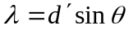 (θ is the diffraction angle.) (1)

De Broglie (1924) proposed that moving material particles could have wavelike properties, and was led to the hypothesis that their ‘wavelength’ could be related to their momentum by
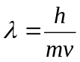 (h is Planck’s constant.) (2)
Can the wave property of a moving particle be demonstrated with a diffraction grating? Yes, if the spacing d’ matches the momentum, (ie. d ‘ ~ ) so that the diffraction angle θ is reasonably greater than zero. With the h there, you can see that the particle has to be small, with a small momentum. An electron is a good candidate. Its momentum can be calculated from its energy: 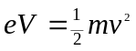 (V is the voltage accelerating the electron,) so
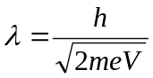 (3)
and, putting in the electron mass and charge, this gives
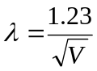 nm (4)

4 kV electrons would have a of 0.02 nm, and gratings with line spacing this small cannot be made mechanically. Natural gratings, in the form of regular crystals, have been used instead – all samples of the same crystal exhibit the same consistent spacing.

In 1912 W.L.Bragg had developed a theory of diffraction of X-rays by crystals (X-rays have
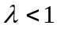 nm.) Crystal atoms form a repeating 3-D lattice, with layers (‘Bragg planes’) of atoms which scatter waves, giving maxima at angles where constructive interference occurs. Bragg’s law for diffraction requires two simultaneous conditions to be true for a maximum:

- 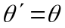 (5a)
- 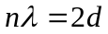sin n = 1, 2, …, (the ‘order’ of the max.) (5b)

where and 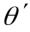 are angles of incidence and scattering, and d the Bragg plane spacing (see fig. 1.) To get good intensity requires the superposition of scattering from many planes of atoms. Because of condition (i) above, the process is usually referred to as Bragg reflection.

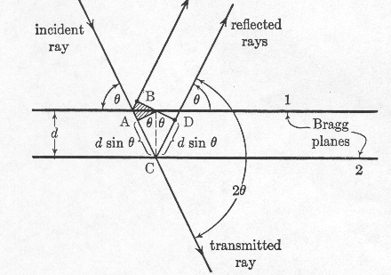

Fig.1 Bragg Reflection. The angle between the incident and reflected ray is 2θ.

W.L.Bragg and W.H.Bragg established the method of X-ray spectrometry by which many crystals have been studied and measured.
The wave properties of matter were first shown experimentally by Davisson and Germer in 1925, using electrons and crystalline nickel.

IV Apparatus
The special Teltron vacuum tube with an electron gun and graphite target has a variable-voltage power supply to give electrons of known energy. The target is a thin deposit of randomly oriented graphite crystals on the surface of a mesh. The electron beam strikes this deposit, and is diffracted according to Bragg’s law by the graphite. The diffracted electrons are made visible as they strike a phosphor-coated screen. See fig.2. The geometry of the tube is shown in fig.3. Don’t expect research-level precision in this apparatus, but you should get within 20% of the accepted value for the C-C spacing.

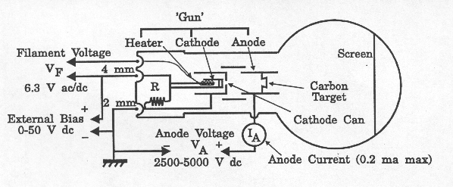

Fig.2 Teltron tube schematic. The Cathode can is negatively biased with respect to the cathode; varying the bias controls the beam current.

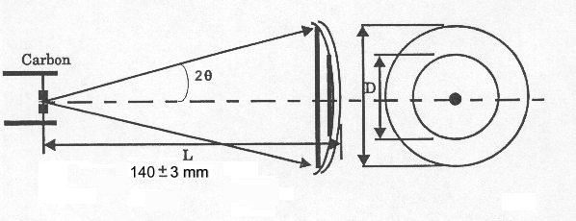
Fig.3 Geometry of diffracted electron beam

V Preparation
- Using Fig.3, calculate the ‘grating spacing’ required with 4kV electrons to give a diffraction spot due to first-order interference at 14 mm from the zero position. Use sin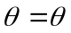 here.

- Do a calculation of the order of magnitude of the distance between C atoms in graphite, as follows: One gram formula mass of C contains Avogadro’s number of C atoms. The density of graphite is about 2000 kg/m³. Find the approximate size of a cubic “box” containing one atom, and hence roughly how far apart the atoms are.

- The actual structure of graphite is shown in Fig.4. It consists of parallel sheets of hex nets of C atoms. Look up the established dimensions of the unit cell, and the C-C spacing in the parallel planes of C atoms (Try an Internet search on ‘Graphite properties’. a, b and c are the traditional designations for the cell dimensions) Is the spacing compatible with the value found in 1. above?
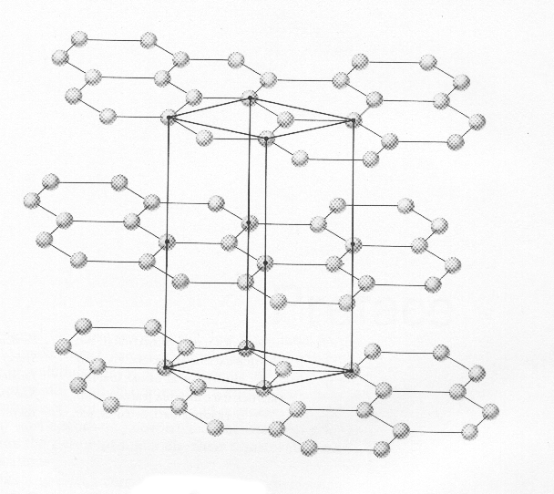

Fig.4 Graphite structure, with Unit Cell. How many C atoms in a unit cell?

VI Precautions
- The voltages in the power supply enclosure exceed 4 kV. Before turn-on, reduce the output to zero, and the (reverse) bias to maximum (~ -30 V) Wait for 30 s after turn-on for the tube heater to warm, increase the accelerating voltage to max., then reduce the bias to increase the beam current until a clear display appears.
- Always use a minimum beam current consistent with visibility, as the focus is sharper (The beam current meter is in the enclosure.) In all cases, do not exceed 0.2 mA, as greater beam currents damage the target.
- If delays occur between measurements, reduce the accelerating voltage to avoid overheating the target or burning the screen phosphor.

VII Experimental Procedure
- Apply power to the tube, adjust for a clear display, and sketch the display. Two rings should be present, and a central bright spot, as in Fig. 3. The central spot is the un-diffracted beam, the rings are due to Bragg reflections from two differently spaced sets of atomic planes. They are rings because the graphite target consists of crystals with all random orientations. The whole pattern may not be centred on the screen if the electron gun is not accurately aligned. This does not matter; the diameters of the rings give the required angles. These are measured by sighting through the grid overlay, or using callipers.

- The rings are up to 5 mm wide: not too good for accurate diameter measurement! Consider the cause of the range of represented by the spread in each ring, and decide whether the diameter should be measured to the inside, outside, or just the middle of each ring. Justify your decision. If you use the grid, check the size of the overlay scale with callipers – it is only a photocopy, and depended on the copier adjustment for accuracy.

- The condition for Bragg reflection (5) in this experimental arrangement can be boiled down to
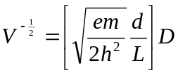 (6)
Measure the diameters of the two rings using about ten accelerating voltage settings ranging from the minimum visible to the maximum available (review Precautions.) Estimate the uncertainty in diameter and voltmeter values (voltmeter has 3% accuracy.) Tabulate the results, including 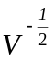, the D’s and their uncertainties.

- Graph vs. D for both rings on the same set of axes. Verify a linear relationship, draw the best-fit lines and obtain the slopes with their uncertainties. Include the origin on the graph when fitting the lines. What is the meaning of the (0,0) point? Check that the uncertainty in a slope is not less than the uncertainty derived from the readings of 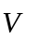and  in eqn (6).

- Use the slopes to find d in eqn (6) for each ring. In interpreting these spacings, we must find regularly spaced planes of atoms satisfying (5). The C-C spacing in graphite is not necessarily the same as the spacing between the Bragg planes. Bragg reflection may occur from the parallel sheets of C atoms in Fig. 4, or from planes formed by rows of C atoms within the sheets. Actually this apparatus does not exhibit the one from the parallel-sheet set, since its spacing is too large (and hence the ring is too small to see on the screen.) Use the attached diagram of a hex net to find regularly spaced rows of C atoms which could serve as Bragg planes. You can find two sets corresponding to the two rings. From the geometry of the regular hexagon, deduce the mean C-C distance from each of the spacings d found from eqn (6). Calculate the uncertainty in this C-C distance.

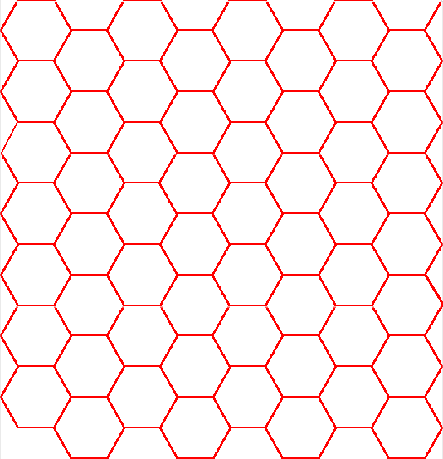

A graphite sheet: a net of regular hexagons

VIII Report
In the Abstract, a reference to the basis of the method used here to measure the C-C distance, and , of course, the value found for this, with its uncertainty.
In the Apparatus description, the functions of the parts of the tube, and how the bias operates.
Draw a diagram like Fig.1 showing better how the incident and reflected beams are oriented in this apparatus, ie. showing 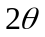as a rather small angle.
Explain how randomly-oriented graphite crystals can produce discrete rings in the Bragg scattering process. At first thought, one might conclude that, with every possible crystal orientation in the target, the screen would be just full of diffracted electrons!
In the Discussion, how this experiment shows both the particle- and wave-properties of the electron. Include a derivation of eqn (6), the meaning of the (0,0) point on the graph, why (quantitatively) reflection due to the graphite inter-sheet spacing is not apparent, and why the rings are a few mm wide.
Include a summary (with reference) of the graphite structure/properties relevant to this experiment found from the literature or Internet search.

Specific Safety Precautions – Electron Diffraction Experiment

Below is a list of risks and controls specific to this experiment. Please read it carefully before commencing the experiment and refer to it as necessary during the course of the experiment.
Further details can be found in the Standard Operating Procedure and Risk Assessment document for this experiment, which is available in the laboratory.

Risk | Control
Cuts from broken glass if Teltron tube is damaged. | Take extreme care when handling Teltron tube.
Exposure to high voltages from experimental equipment | Do not touch high voltage terminals when power is applied.  Check high voltage cables for frayed insulation or visible signs of deterioration prior to use.  Reduce high voltage supply except when specifically required.
Exposure to dangerous voltages from faulty equipment | Do not use faulty equipment.  Report faulty equipment to demonstrator immediately.  Check all power cords for visible deterioration prior to use.
Trip hazard due to wires trailing over bench edges. | Do not let long wires dangle over bench edges.
Trip hazard due to obstructions in walkways. | Keep bags under benches to avoid obstructions.

Course : PHYS2170 Quantum Mechanics and Semiconductor Physics

Laboratory 4: Hall Effect
Assessable  items for this  Laboratory | Comments | Maximum Marks:
Workbook | Your Workbook must include :  Date you did the experiment :  Name of experiment :  Your lab work including :  Theoretical concept, formula and the laboratory goals;  Sketch/diagram/photo of lab apparatus, equipment including labelling;  Record of all your experimental notes, details, observations, collected data;  Essential diagrams, graphs (rough or spreadsheet), calculations;  Error estimation and method used;  All graphs and tables must be label,  Conclusion: clear experimental result including error and unit  All inserts must be glued, stapled or sticky taped into the appropriate places of your workbook  Your workbook must be signed by your demonstrator before leaving the laboratory. | 10
Report | The final report should have a title, an author name, and a date. It should include an abstract, an introduction, a brief discussion of the techniques and procedures, a section in which the results are presented and one in which the implications of the results are discussed and conclusions presented.  The abstract should be short (typically 5 lines of text), including an outline of the objectives and the main results and conclusions. The introduction should include brief discussions of the underlying physics and the link between the latter and the experimental techniques. In a separate section, the techniques and procedures should be outlined with the help of clearly labelled diagrams.  Tables of raw data should not be reproduced in the final report, but all the graphs must be included. The report must also be self-contained and written in your own words (do not refer to materials that are in your workbook, and do not reproduce materials from this handout except for the figures). As a guide, include enough information that would allow the experiment to be repeated by someone who is not familiar with the objectives, experimental set-up and techniques, analytical procedures, and so on. | 15

Lab 4: INVESTIGATIONS OF THE HALL EFFECT IN SEMICONDUCTORS

I Aim
To investigate the Hall effect in semiconductors and determine the number densities and mobilities of charge carriers in two semiconducting samples, one of which is n-type and the other p-type.

II Introduction
Doped semiconductors are classed as n-type or p-type depending on whether the majority charge carriers are electrons or holes respectively (an outline of semiconductor doping is given in the appendix). For both n-type and p-type semiconductors, the electrical conductivity can be controlled by adjusting the dopant concentration during manufacture. However, the electrical properties of doped semiconductors are characterised not only by the conductivity but also by the mobility of the charge carriers. The mobility is a measure of the ability of charge carriers to move through a semiconductor.

The conductivity, σ, of a sample is related to the number density, n, of the charge carriers by the following expression [1]:
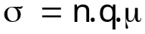 ()
where q is the carrier charge and μ is the charge mobility. It is therefore not possible to determine both the carrier number density and the mobility from electrical conductivity measurements since n and μ appear as a product in equation . It is also not possible to deduce whether the charge carriers are electrons or holes.

In contrast, the carrier type and number density can be determined from Hall voltage measurements, and the mobility of the charge carriers can also be obtained if the conductivity of the semiconductor sample is known.

The objectives of this experiment are to investigate the Hall Effect in doped semiconductors, and determine the following:

- the type of majority charge carriers (electrons or holes) for two samples of doped semiconductors (i.e. determine whether the semiconductors are n-type or p-type).
- the number densities of the charge carriers
- the mobility of the charge carriers

III The Hall Effect
In 1879, Edwin H. Hall discovered that a small voltage appears across a current carrying conductor which is in a magnetic field. The phenomenon, which is called the Hall effect, is characterised by a voltage which appears in a direction perpendicular to both the current and the magnetic field.

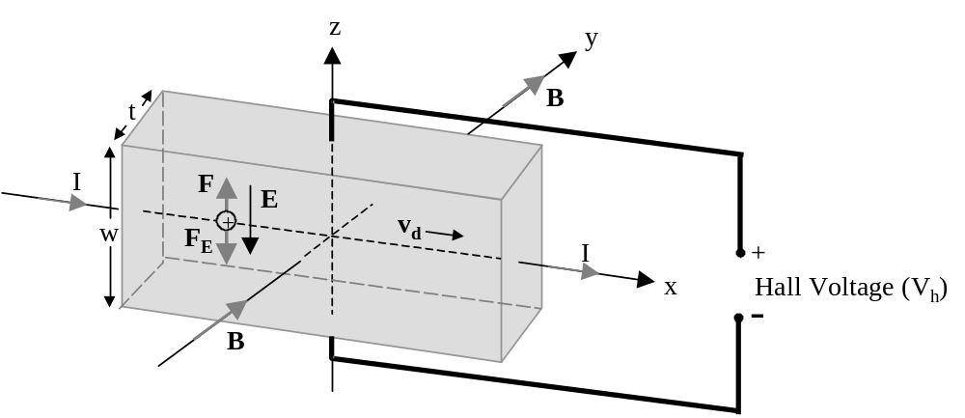
Figure 1. Schematic diagram illustrating the principle of the Hall Effect for p-type
semiconductors.

Figure 2. illustrates the principle behind the Hall effect for p-type semiconductors, in which holes are the majority charge carriers. A current, I, flows in the x-direction and a magnetic
field, B, is applied in the y-direction. The drift velocity of the charge carriers in the x-direction is v_{d}. In this configuration the charges experience a force F which is given by:
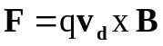 ()
Since this force is in the z-direction, the positive charge carriers are deflected towards the top edge of the sample which acquires a positive charge relative to the bottom edge. This results in a potential difference across the sample. The accumulation of positive charges at the top edge results in an electric field E and a force F_{E} on the positive charge carriers in the negative z-direction. This accumulation of charge continues until a state of equilibrium is reached when the force arising from the magnetic field is balanced by that due to the electric field (i.e. F = F_{E}). The charge carriers are then no longer deflected upwards and the voltage difference between the top and bottom edges of the sample is the Hall Voltage V_{h}.

Assuming that the directions of the current I and magnetic field B are as shown in figure 3, discuss the following in your workbook:
- the direction of the force F for an n-type semiconductor ? Justify your answer.
- how would the polarity of the Hall voltage for an n-type semiconductor compare with that shown in figure 4 for a p-type semiconductor assuming that the directions of the current and magnetic field are maintained?

The Hall Coefficient
With reference to figure 1, the total force on a charge carrier with charge q is given by:
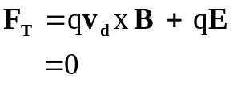 ()
where bold letters represent vectors and it is assumed that equilibrium has been reached. For the coordinate system used in figure5, equation reduces to:
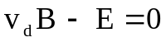 ()
In terms of the dimensions of the sample (see figure 6) and the number density, p, of positive charge carriers, the current, I, through the sample can be expressed as:
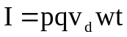 ()
The electric field, E, is given by:
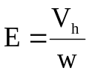 ()
where V_{h} is the hall voltage. Using equations , and , the hall voltage can be written as:

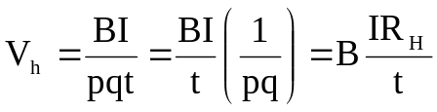 ()
The factor 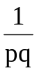 is known as the Hall coefficient R_{H}.
Equation shows that if the Hall voltage V_{H} is measured as a function of the magnetic field B for constant current I, the carrier number density, p, can be determined if the thickness, t, of the sample is known.

A similar expression can be derived for V_{H} if the sample is an n-type semiconductor and the charge number density is n. In this case the Hall coefficient is, by convention, given by:
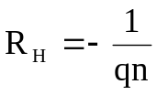 ()
The Hall Mobility
Except for large electric fields, the drift velocity, v_{d,} in the x-direction is related to the electric field E_{x} also in the x direction by:
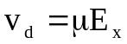 ()
where the constant of proportionality μ is the mobility.

The electric field E_{x} is related to the current density J_{x} by:
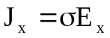 (σ is the conductivity) ()
Using equation J_{x} can also be written as:
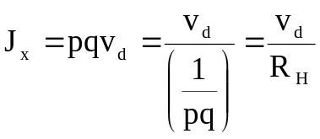 ()
Using equations , , and to eliminate E_{x}, J_{x} and v_{d} results in the following expression:
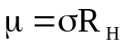 ()
If the conductivity σ is known and R_{H} is determined from equation , the mobility μ can be calculated. The conductivity is usually determined from the resistance and dimensions of the sample, but in this experiment the conductivities of the samples are known and will not be measured.

Possible Sources of Errors
So far it has been assumed that the electrical contact points on the sample across which the Hall voltage is measured are perfectly aligned. If that is not the case, as illustrated in figure 7, a voltage appears across those two points even in the absence of a transverse magnetic
field because of the resistivity of the sample. This introduces an error in the measured Hall voltage.

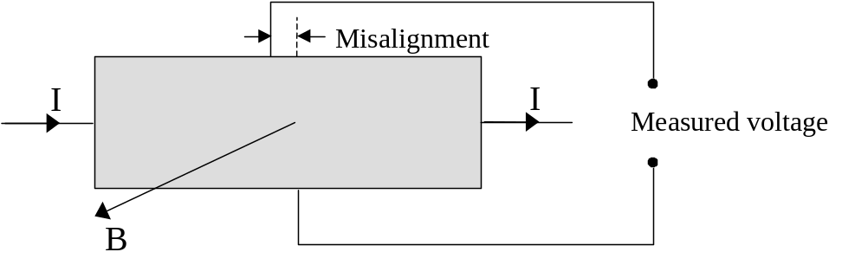

Figure 8. Misalignment of contact points that results in an offset voltage.

This voltage offset can be eliminated as follows:

- The Hall voltage V_{H1} is measured for some chosen directions of the current and magnetic field.
- The Hall voltage V_{H2} is then measured for the same current direction, but with that of the magnetic field reversed.
- The corrected Hall voltage is given by:
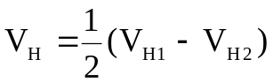 ()
In your workbook, show that the Hall voltage reverses sign if either the current or magnetic field direction is reversed, but the voltage offset reverses sign only if the current direction is reversed. Use the information to confirm the validity of equation .

Why is it not sufficient to determine V_{H} by subtracting the voltage for zero magnetic field from the measured voltages?

There are three other potential sources of errors that must be considered. These arise from the Ettingshausen, Nernst and Righi-Leduc effects.

The Ettingshausen effect is due to a spread in the velocities of the charge carriers. The more energetic charge carriers have higher velocities and are deflected more than less energetic carriers. In the z-direction, this creates a temperature gradient which gives rise to a thermoelectric effect resulting in an electric field E_{T} and, consequently, an additional voltage that is distinct from the Hall voltage. The electric field is given by an expression of the form [2]:
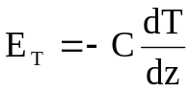 ()
where C is the Thomson Coefficient.

The Nernst effect is due to a temperature gradient in the x-direction. This results in a current flowing in the x-direction and, consequently, a voltage in the z-direction due to the Hall effect. The thermoelectric effect arising from the Nernst effect is called the Righi-Leduc effect. The latter is analogous to the Ettingshausen effect.
The polarity of the voltage from the Ettingshausen effect changes with reversal of both the current I and magnetic field B directions. For the Nernst and Righi-Leduc effects, the polarity of the respective voltages changes only if the direction of the magnetic field is reversed. For these reasons a correction for the Ettingshausen effect cannot be made by reversing the direction of either the current or magnetic field, but corrections can be made for the Nernst and Righi-Leduc effects by repeating the Hall voltage measurements with the current direction reversed. Error voltages arising from the Ettingshausen effect can be addressed by using an alternating current I whose period is short compared to the thermal time constant of the sample.

In this experiment, error voltages that are due to the Ettingshausen, Nernst and Righi-Leduc effects will be ignored as they are not as important as the voltage offset resulting from misalignment of the electrical contacts.

IV Calibration of the Electromagnet

The experimental set-up consists of the following pieces of equipment:

- two semiconductor samples numbered #1220 and #1221 respectively. These samples are mounted as illustrated in figure 9 and, henceforth, the mounted samples will be called the semiconductor probes.
- a unit consisting of a digital multimeter and constant current source ( model DHE-21)
- an electromagnet (model EMU-50)
- an electromagnet power supply (model DPS-50)
- a digital Gaussmeter (model DGM-102)
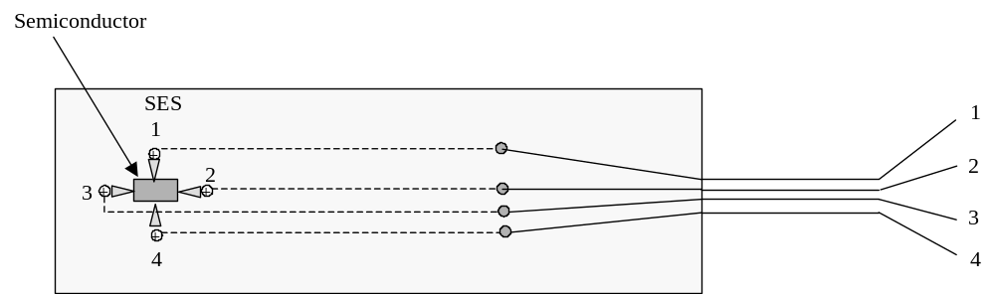
Figure 10. Schematic diagram showing the probe connections, and numbering of the
electrical leads.

In this part of the experiment the electromagnet is calibrated. The results of the calibration are, subsequently, used in the Hall voltage measurements.
Measure the magnetic field as a function of the electromagnet current using the following procedure:
- Adjust the gap between the pole pieces of the electromagnet to approximately 25mm using the knobs at the ends of the assembly.
- Connect the electromagnet to the power supply (DPS-50). Check that the coils of the electromagnet are connected in series.
- Remove the Gaussmeter probe from the storage area at the rear of the display unit DGM-102. Switch on the meter and zero the probe.
- Mount the Gaussmeter probe in one of the holders provided. Remove the probe cap and locate the probe sensor at the centre of the gap between the electromagnet pole pieces.
NOTE: THE ELECTROMAGNET CURRENT MUST BE SET TO ZERO
BEFORE SWITCHING THE POWER SUPPLY ON OR OFF
- Make sure that the current is set to zero by turning the current adjustment knob fully counterclockwise, then switch on the power supply.
- Measure the magnetic field as a function of the current through the electromagnet over the range from zero to 4A in steps of 0.25A. Note that the magnetic field is displayed in Gauss and must be converted to Tesla.
- Note the direction of the current through the electromagnet and the direction of the corresponding magnetic field. If the magnetic field indicated by the Gaussmeter is positive, the pole facing the side of the probe marked “N” is the south pole.
- Reduce the current to zero and turn off the electromagnet power supply.
- Using Microsoft Excel, plot a graph of the magnetic field, in Tesla, against the electromagnet current and generate a linear regression fit for the data set (i.e. obtain an equation that relates the magnetic field to the current).

V Investigations of the Hall Effect

NOTE: The semiconductor samples are fragile and should be handled with
care. The semiconductor probes should be taken out of the storage box only
when required and should not be left on the workbench when not in use.

In this part of the experiment, the Hall voltage is measured as a function of the magnetic field for a fixed current through the semiconductor samples. The results are used to determine the charge carrier types, and the carrier number densities and mobilities.

Semiconductor Probe #1220

- Select probe #1220 and, carefully, mount it in the holder provided so that the edge marked SES is at the top. Make sure that the leads do not snag on the metal tab.

- Insert the probe in the space between the poles of the electromagnet so that the semiconductor sample is roughly at the centre of the gap. Connect the probe to the unit consisting of a digital multimeter and a constant current source (Model DHE-21) as illustrated in figure 11.

- ASK A DEMONSTRATOR TO CHECK THE CONNECTIONS BEFORE PROCEEDING FURTHER.

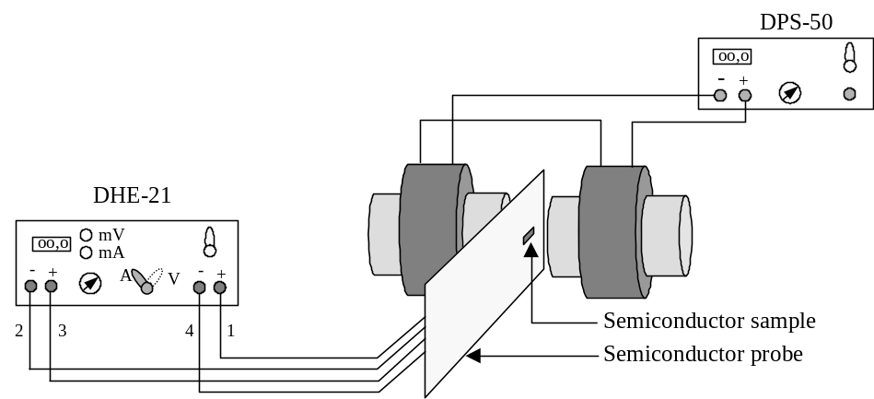
Figure 12.Schematic diagram of the experimental set-up. The numbers, 1,2,3 and 4 refer to the numbers assigned to the leads in figure 13.

- Set the current to zero and switch on the unit (DHE-21). Slowly, raise the current I through the semiconductor sample to 5mA (DO NOT EXCEED 10mA).

- Check that the electromagnet current is set to zero and switch on the electromagnet power supply.

- Measure the Hall voltage for electromagnet currents ranging from zero to 4A in steps of 0.25A. This range corresponds to magnetic fields within the range from zero to approximately 3,400 Gauss (zero to 0.34 Tesla).

- In your workbook, draw a sketch of the semiconductor probe showing the direction of the current through the sample, the direction of the magnetic field, and the polarity of the Hall voltage.

- Reduce the electromagnet current to zero, and reverse the direction of the magnetic field by swapping the leads at the electromagnet power supply. Repeat parts (vi) and (vii) for the new direction of the magnetic field.

- Reduce the electromagnet current and the current through the sample to zero. Switch off the electromagnet power supply and the sample current source.

- For each value of the magnetic field, use equation to calculate the Hall voltage, V_{H}, corrected for the error voltage arising from misalignment of the electrical contacts on the semiconductor sample.

- Plot a graph of the Hall Voltage V_{H} against the magnetic field B and determine the following (including the uncertainties):
- the Hall coefficient R_{H} (the sample thickness is listed on the attached data sheet)
- the number density of the charge carriers
- the mobility μ of the charge carriers (the resistivity of the sample is listed on the attached data sheet)
- the charge carrier type (i.e. electrons or holes) and the semiconductor type (n-type or p-type)
Semiconductor Probe #1221

Disconnect probe #1220 and place it in the storage box provided. Mount probe #1221 in the holder and repeat the procedures in section V, parts (ii) to (xi).

VI Discussion and Final Report

The final report should have a title, an author name, and a date. It should include an abstract, an introduction, a brief discussion of the techniques and procedures, a section in which the results are presented and one in which the implications of the results are discussed and conclusions presented.
The abstract should be short (typically 5 lines of text), including an outline of the objectives and the main results and conclusions. The introduction should include brief discussions of the underlying physics and the link between the latter and the experimental techniques. In a separate section, the techniques and procedures should be outlined with the help of clearly labelled diagrams.
Tables of raw data should not be reproduced in the final report, but all the graphs must be included.
The report must also be self-contained and written in your own words (do not refer to materials that are in your workbook, and do not reproduce materials from this handout except for the figures). As a guide, include enough information that would allow the experiment to be repeated by someone who is not familiar with the objectives, experimental set-up and techniques, analytical procedures, and so on.
The discussion should include the following:
- whether the Hall effect applies to undoped (intrinsic semiconductors)
- evidence from this experiment that holes are, in fact, positive charge carriers as predicted by quantum mechanics
- the effect of the spread in carrier velocities on the Hall coefficient. In this experiment, it has been assumed to be negligible.
- practical applications of the Hall effect
Discussions of the above items in your report should not be itemised but should be included in the text where appropriate.
The entries in the laboratory workbook will contribute 40%, and the final report 60 % towards the final mark for this experiment.

VII References

[3] Melissinos, A., “Experiments in Modern Electronics”, Academic Press, New York,
1966.
[4] McKelvey, J., “Solid State and Semiconductor Physics”, Robert E. Krieger Publishing
Company, Florida, 1982.

[3] Putlet, E., “The Hall Effect and Semiconductor Physics”, Dover Publications, New
York, 1960.
[4] Hunter, L., Ed., “ Handbook of Semiconductor Electronics”, McGraw-Hill Book
Company, Inc., New York, 1962.
[5] Neamen, D.A., “Semiconductor Physics and Devices: Basic Principle”, Third Edition Chapter 5.4, McGraw-Hill Higher Education.
VIII Appendix

Undoped (Intrinsic) Semiconductors
Semiconductors are crystalline solids whose conductivities are due to both negative (electrons) and positive charge carriers (holes). Figure 1 shows the energy band structure of an undoped semiconductor. The lower band is known as the valence band and the upper band as the conduction band. When an electron makes a transition from the valence band to the conduction band an empty state, referred to as a hole, is created in the valance band. Since an electron in the valance band can move freely into the empty state, a hole behaves
as a positive charge carrier which moves freely within the lattice, and carries a charge whose magnitude is the same as that carried by an electron.
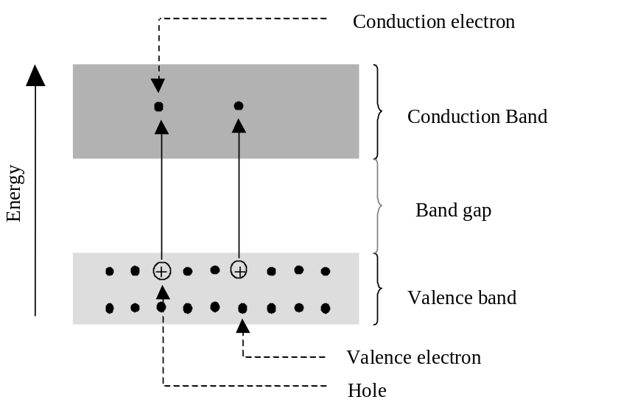
Figure 2.Energy band diagram for an intrinsic semiconductor showing the formation of electron-hole pairs.

Pure (undoped) semiconductors contain equal numbers of conduction electrons and holes. The combination of a conduction electron and the corresponding hole is referred to as an electron-hole pair. Pure semiconductors that are characterised by the presence of such electron-hole pairs are known as intrinsic semiconductors. In an electric field, holes drift in the direction of the field and electrons in the opposite direction.

Doped (Extrinsic) Semiconductors

The energy band structure and, consequently, the conductivity of semiconductors can be changed by the addition of specific impurity atoms in controlled concentrations.

n-Type Doping

In the case of n-type doping of silicon, the dopant atoms are chosen from elements in group V of the periodic table. These elements (e.g. P, As, Sb) all have five valence electrons. If such an element (e.g. P) is substituted for a silicon atom in the semiconductor lattice, four of the five valence electrons form covalent bonds with the four nearest neighbours. The fifth valence electron, which is not involved in covalent bonding, is weakly bound and, at room temperature, is free to move within the lattice as a negative charge carrier. In essence, the dopant atom gives an electron to the lattice and is, therefore, referred to as a donor atom.

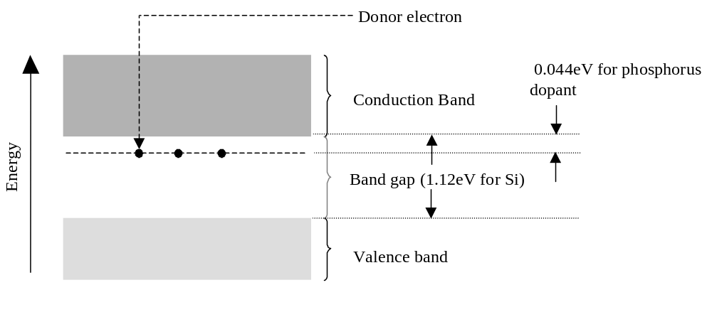
In terms of the energy band model, the situation is as shown in figure 3 . The energy level of the extra electron lies just below the conduction band and is, therefore, within the band gap. Since the difference between the energy of the bottom edge of the conduction band and that of the electron is relatively small (typically 0.04eV compared to a band gap of 1.12eV for silicon), the electron requires only a relatively small amount of energy to make a transition to the conduction band. In this way, the conductivity of the semiconductor is increased.
Figure 4. Energy band diagram for a semiconductor lattice doped with donor
atoms (e.g. phosphorus).

Semiconductors which have been doped with donor atoms are known as n-type semiconductors because the majority charge carriers are electrons which carry a negative charge.

p-Type Doping

Elements from group III of the periodic table (e.g. B, Al, Ga, In) have three valence electrons. If a semiconductor lattice such as that of silicon is doped with one of the above elements, the three valence electrons form three covalent bonds with three neighbouring atoms but, unlike the case of n-type doping, there is a deficiency of one electron (or, equivalently, a hole is formed) because the fourth bond is incomplete. Since the hole can be easily filled by an electron from an adjacent lattice atom, it behaves as a positive charge carrier and the conductivity is increased. The dopant atom is known as an acceptor atom because it accepts an electron in order to complete its bonding,.

The energy band model is illustrated in figure 5. The doping of a semiconductor by acceptor atoms result in the formation of acceptor energy levels just above the valence band.
Consequently, at room temperature, electrons in the valence band have enough energy to make transitions to these levels, resulting in the formation of holes in the valence band. Semiconductors which have been doped with acceptor atoms are known as p-type semiconductors because the predominant charge carriers are holes which carry a positive charge.

Semiconductors in which conduction is predominantly due to electrons and holes resulting from doping with donor and acceptor atoms respectively are known as extrinsic semiconductors.
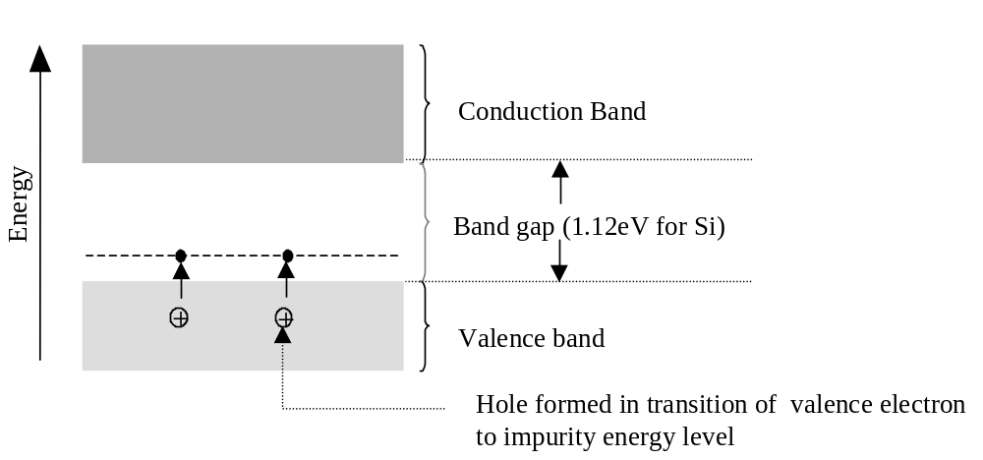
Figure 6. Energy band diagram for a semiconductor lattice doped with acceptor
atoms (e.g. boron).

In n-type semiconductors, the main charge carriers are electrons and the latter are, therefore, referred to as the majority carriers. Holes are minority carriers. The reverse is the case for p-type semiconductors in which holes are the majority carriers and electrons the minority carriers.
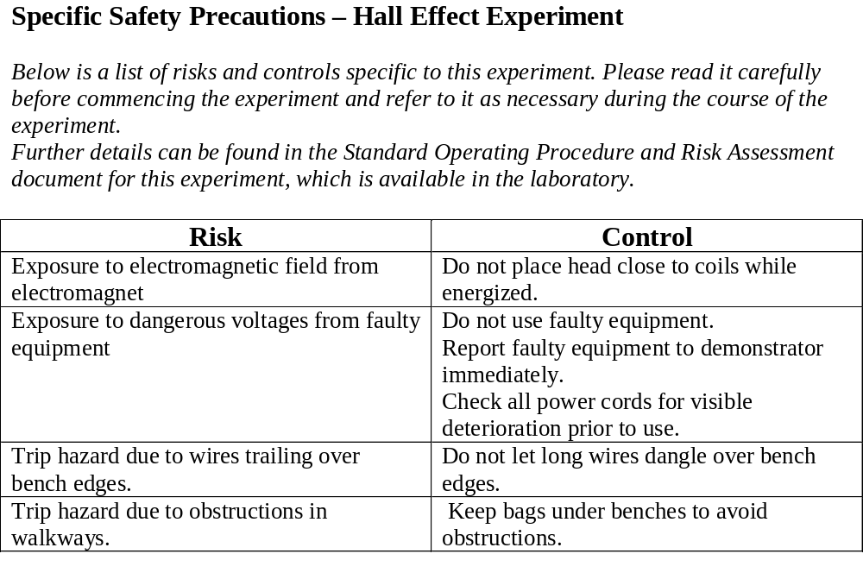

Data Sheet

Sample No. | #1220 | #1221 | #1446 | #1450 | #1472 | #1474
Crystal material | Germanium | Germanium | Germanium | Germanium | Germanium | Germanium
Resistivity (Ohm.cm) | 5.0 | 9.0 | 5.5 | 10.0 | 5.0 | 9.0
Sample thickness (mm) | 0.50 | 0.50 | 0.50 | 0.50 | 0.50 | 0.50
Maximum current (mA) | 10 | 10 | 10 | 10 | 10 | 10

Course : PHYS2170 Quantum Mechanics and Semiconductor Physics
Laboratory 5: Measurement of Band Gap
Assessable  items for this  Laboratory | Comments | Maximum Marks:
Workbook | Your Workbook must include :  Date you did the experiment :  Name of experiment :  Your lab work including :  Theoretical concept, formula and the laboratory goals;  Sketch/diagram/photo of lab apparatus, equipment including labelling;  Record of all your experimental notes, details, observations, collected data;  Essential diagrams, graphs (rough or spreadsheet), calculations;  Error estimation and method used;  All graphs and tables must be label,  Conclusion: clear experimental result including error and unit  All inserts must be glued, stapled or sticky taped into the appropriate places of your workbook  Your workbook must be signed by your demonstrator before leaving the laboratory. | 10
Report | The report should contain Abstract, Introduction, Procedure, Results, Discussion and Conclusions.  The Abstract will give a very brief overview of the principle of the method method used to obtain , and include your actual results. The Introduction will give some background to the theory and equations that is needed to understand the experiment. The procedure is a brief description of the method. The aim here is not to repeat the instructions in the manual, but to give a very short overview so that a scientifically literate person can understand what was done. Include any points to note about technique; difference between heating and cooling values, and any implications of this, should be noted here. A schematic block diagram of the apparatus, sample, probes and their connections (not a ‘picture’ of the equipment) should also be included.  The results section includes sample calculations and graphs, properly titled, with labelled axes and units. Also include details of the probe and sample dimensions. It is expected that the results will be displayed using the spreadsheet plot. The final section includes a discussion of any factors or limitations that may have affected the accuracy of the experiment, the interpretation of the final result. | 10

Lab 5: MEASUREMENT of the BANDGAP in Ge

I AIM
The properties of doped semiconductor materials depend on the intrinsic material, and the extrinsic, or doping, elements. For solid state devices fabricated from such materials, the most important properties are associated with the conductivity. This is most influenced by the energy bandgap between the valence- and the conduction- bands. The purpose of this experiment is to find the bandgap in a sample of Ge, using a four-probe technique to measure the variation in conductivity with temperature.

II REFERENCES
Neamen D.A., “Semiconductor Physics and Devices: Basic Principle”, Third Edition, McGraw-Hill Higher Education. Chapter 4 and 5.
Scientific Equipment & Services: Resistivity of Semiconductors by Four Probe method at different temperatures
Scientific Equipment & Services: Four Probe Set-up Equipment Test Report
Van Zeghbroeck, B: Principles of Semiconductor Devices
Especially part of Ch.2: http://ece-www.colorado.edu/~bart/book/eband5.htm

III APPARATUS
Four probe set, comprising control box, oven and sample holder.
Thermometer, 0 – 200ºC.
n-type Ge sample slice, with non-conducting bottom surface.
Sample thickness W = 0.50 mm.
Probe spacing S = 2.00 mm.
Scientific Equipment & Services Four-Probe apparatus manual.

IV INTRODUCTION
In solids, atoms are arranged in an ordered, dense packing, forming a crystal. Silicon, germanium and carbon crystals have identical structure, called diamond structure. A potential energy diagram for a real crystal contains a multitude of energy levels. This is because the interaction between overlapping wave functions for nearby atoms causes energy levels to split and spread. A solid of N atoms has N times as many energy levels. The tremendous number of atoms in a crystal (~10²² cm⁻³) therefore results in bands of a continuum of levels. The bandgap, E_{g}, or forbidden region, separates the valence band and the conduction band.

At absolute zero temperature the bands below the energy gap are completely filled and the conduction band is empty. Thus no conduction takes place. A semiconductor has a bandgap of order 1 eV (electron-volt = 1.6 x 10⁻¹⁹ J). With increasing temperature, thermal agitation causes some electrons gain energy greater than E_{g} and move into the conduction band, leaving a hole in the valence band. Both the conduction electrons and valence band holes contribute to conduction in the presence of an applied electric field. This is called intrinsic conduction. The electrical conductivity, σ, of a semiconductor is thus the sum of the contributions of both the charge carriers, negative (‘n’) electrons and positive (‘p’) holes:
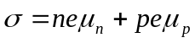 (1)
where e is the electronic charge, n and p are the number of charge carriers per unit volume, and the μs are the mobility of the ‘n’ or ‘p’ charge carriers. Mobility is actually the average drift velocity per unit electric field, μ = v_{d} /|E|. In silicon μ~10² cm²/V-s and v_{d} ~10⁷ cm/s. The mobility actually varies with temperature and charge carrier so for Ge we will use the values

μ_{n}=5.05x10⁷ T^{-1.66} cm² V⁻¹ s⁻¹ (2)
μ_{p}=1.12x10⁹ T^{-2.33} cm² V⁻¹ s⁻¹ (3)

To enhance the conduction, and other properties, the pure material is doped with n- or p-type impurity elements (resulting in extrinsic as well as intrinsic conduction). At room temperature, the conduction is mostly by the extrinsic dopant, but as the temperature is increased, the intrinsic conduction mechanism dominates. The effect of the dopant is to greatly reduce the bandgap, to ~0.05 eV (compare with the average thermal kinetic energy of an electron at room temperature kT: ~0.026 eV, where k is Boltzmann’s constant).

For a pure crystal, ie. no extrinsic conduction, it can be shown that the intrinsic carrier density is
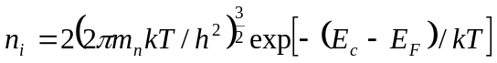 (4)
where the subscript i implies ‘intrinsic’, m_{n} is the mass of the charge carriers (electrons) at the bottom of the conduction band, E_{c} is their energy, and E_{F} is the Fermi level energy, midway between the valence and conduction bands.

Similarly, 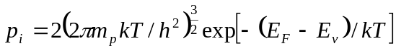 (5)
where m_{p} is the mass of the positive charge carriers (holes) at the top of the valence band, and E_{v} is their energy

Obviously 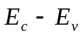 is 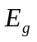, the bandgap.

The product 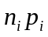 gives an interesting expression:
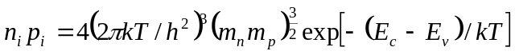 (6) 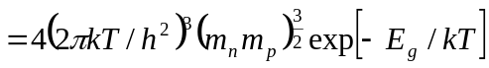 (7)

The term before the exponential is almost constant compared with the exponential, and is often represented by a ‘pseudo constant’ 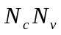 over a restricted temperature range.

Also, in an intrinsic (pure crystal) conductor, 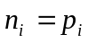, so that
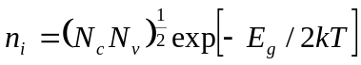 (8)

and hence the conductivity equation can be written
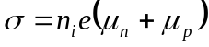
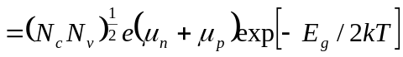 (9)
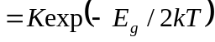 (10)
where K is nearly constant in some temperature range.
We finally arrive at the relation
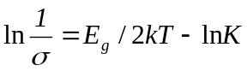 (11)
so may be obtained from the slope of 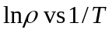 where ρ is the resistivity,
ρ 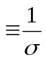. (11a)

If the semiconductor sample is doped, i.e. has an extrinsic conductive component, then n,p ≠ n_{i,.} Indeed for an n-doped semiconductor (as in this experiment), with donor number density N_{D},
n = p + N_{D} (12)

Now since np=n_{i}² (13)
combining (12) and (13) we have

n = (N_{D}+(N_{D}²+4n_{i}²)^{0.5})/2 (14)

Note that for Ge at about 300K a good approximation for n_{i} is

n_{i} = 1.76x10¹⁶ T^{1.5} exp(-4550/T) cm⁻³ (15)
By combining equations 1, 11a and 12-15 we find that, where extrinsic conduction dominates, the plot of ln ρ vs. 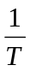 will be nearly constant. So a plot of ln ρ vs.1/T will comprise a region which is nearly flat (where extrinsic conduction dominates) and a region which is linear (where intrinsic conduction dominates).

In this experiment the resistance of a Ge sample is measured as a function of temperature in order to find the variation of ρ with T, and hence E_{g} and N_{D}. The experimental technique has some important limitations and assumptions. These are listed on p.5 –10 of the apparatus manual and reproduced here in the Appendix. The experiment employs a four-probe method, with current and voltage contacts in a straight line, as shown in the Appendix Fig.5. The current I flows between the outer contacts in a certain pattern in the body of the material, and the resulting voltage V between the inner potential contacts is measured. Having separate current and potential connections overcomes problems with contact potentials which exist where the current is injected.
 is computed from 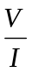 and the geometry of the sample. Three cases are explored on p. 7-10 of the manual. The resistivity of the Ge is times a function G of the dimensions of the sample. The three cases are slices of Ge with width large compared to S, the probe spacing:
1. Large () volume sample, with large thickness W: 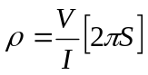
2. Flat slice, thickness W small, bottom surface plated with conducting material: 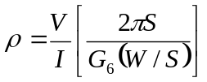
- Flat slice, thickness W small, bottom surface non-conducting: 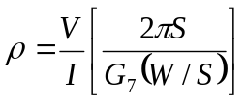

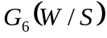 and 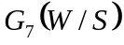 are functions of the ratio 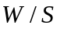, found from Table I of the appendix, by linear interpolation. A rough confirmation of your calculations may be obtained from Figs 8 and 9.

V PRECAUTIONS
The Ge crystal is thin and brittle. Read before handling, and follow, the suggestions in the Experimental Procedure section. Do not contaminate the sample by touching the surface with the fingers; hold it with the mica insulating base.

VI EXPERIMENTAL PROCEDURE
- The Four-probe Setup box supplied by Scientific Equipment and Services, contains an adjustable constant current source (up to about 20 mA), a millivoltmeter, and an oven heater having two levels of control, ‘L’ (low) and ‘H’. Ensure oven power is OFF (sw UP) on the Setup box, and plug in the oven. Record the serial number of your setup box. Describe the Ge sample, recording its specs and dimensions. The millivoltmeter has two ranges for voltage measurement, x1 and x10. It will measure the constant current value in mA when switched to Current position.

- Connect the constant current supply to the outer probes (R – Bk wires) and the inner probes (Y – Gn wires) to the millivoltmeter terminals. Match the plug/socket colour coding for correct polarity. Apply power to the Setup box (Oven OFF – sw UP.)
Set the probe mounting fixture on the bench and raise the probe cylinder, holding it up with the grub screw. Carefully place the sample on the base plate. The sample has an insulating sheet (mica) on its bottom surface. Hold the probe cylinder while backing off the grub screw, gently lower the probe points until they touch the sample, then depress the spring-loaded points a further ≈ 1 mm. Tighten the grub screw. Minimum pressure consistent with a good contact is the goal. Check for current flow and a voltage reading. If OK, place the holder with sample in the oven, and insert thermometer in oven.

At this stage the work should be shared between the partners. One student should take the measurements in 3 while the other student should prepare the spreadsheet in 4.

- Select Current measurement, and adjust to a suitable value in the range 5 - 6 mA. Select Voltage measurement, and prepare a table in your workbook to record temperature and probe voltage values for about 40 pairs of readings. Turn the oven ON at the HIGH heating rate, and allow the oven to come up to 170°. When the system has reached thermal equilibrium at this temperature, turn off the oven and record the temperature and voltage as the sample cools. (A good regime is to take readings every 5 degrees for about down to 50ºC then every 2 degrees to room temperature). Periodically check the current, to ensure it remains constant. This is important!

- Using EXCEL plot a graph of your experimental results for ln() vs 1/T. Remember T is absolute temperature in Kelvin. Table 1 lists values of the parameter G for various values of the ratio W/S. On the same plot, put values of lnρ calculated using formulae (1), (2), (3), (11a), (12), (13), (15). This calculation requires the dopant concentration N_{D} to be entered. Assume a trial value of 1x10¹⁵ cm⁻³ and adjust this value until a good fit is found between experiment and calculation.

- Use the value of the slope to estimate 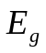 in eV. Use your fit to the data to evaluate the doping concentration. Indicate on your graph the regions of intrinsic and extrinsic conduction.
- Copy the spreadsheet formula for each calculation column at the end of the data tabulation and paste the spreadsheet data into your Workbook. Prepare the graph for the Report.

VII REPORT
The report should contain the following sections: Abstract, Introduction, Procedure, Results, Discussion and Conclusions.

The Abstract will give a very brief overview of the principle of the method used to obtain , and include your actual results. The Introduction will give some background to the theory and equations that is needed to understand the experiment. The procedure is a brief description of the method. The aim here is not to repeat the instructions in the manual, but to give a very short overview so that a scientifically literate person can understand what was done. Include any points to note about technique; difference between heating and cooling values, and any implications of this, should be noted here. A schematic block diagram of the apparatus, sample, probes and their connections (not a ‘picture’ of the equipment) should also be included.

The results section includes sample calculations and graphs, properly titled, with labelled axes and units. Also include details of the probe- and sample dimensions. It is expected that the results will be displayed using the spreadsheet plot. The final section includes a discussion of any factors or limitations that may have affected the accuracy of the experiment, the interpretation of the final result, and answers to the questions below.

VIII QUESTIONS

- Compare the four-probe method with a measurement technique based on soldering wires onto a sample for resistivity measurements.

- Why does a semiconductor behave as an insulator at zero K?

- What characteristic of the millivoltmeter would be of importance in this experiment?
APPENDIX

EXPERIMENTAL CONSIDERATIONS
- High resistance of rectification appears fairly often in electrical contacts to semiconductors and in fact is one of the major problems.
- In single crystal material the resistivity may vary smoothly from point to point. In fact this is generally the case. The question is the amount of this variation rather than any question of its presence. Often, however, it is conventionally stated that the resistivity is constant within some percentage and when the variation does in fact fall within this tolerance, it is ignored.
- Soldered probe contacts may disturb the current flow shorting out part of the sample and add to the ambiguity in the measurement of the probe spacing. Soldering directly to the body of the sample can affect the sample properties by heating effect and by contamination unless care is taken. These problems can be avoided by using pressure contacts. The principal drawback of contacts are that they may be noisy.
- The current through the sample should not be large enough to cause heating. A further precaution is necessary to prevent ‘injecting effect’ from affecting the measured value of ρ. Even good contacts, to germanium, for example, may inject. This is minimised by keeping the voltage drop at the contacts low. If the surface near the current contacts is microscopically ‘rough’ (lapped surface) and the electric flow in the crystal is low, these injected carriers will recombine before reaching the voltage-measuring probes.

Since ρ is independent of current, it is possible to determine whether or not any of these effects are interfering by measuring ρ at several values of I. It should be kept in mind that these points of experimental technique affect essentially all the measurements and not the resistivity measurements only.

FOUR PROBE METHOD

Many conventional methods for measuring resistivity are unsatisfactory for semiconductors because metal-semiconductor contacts are usually rectifying in nature. Also there is generally minority carrier injection by one of the current carrying contacts. An excess concentration of minority carriers will affect the potential of other contacts and modulate the resistance of the material.

The method described here overcomes the difficulties mentioned above and also offers several other advantages. It permits measurements of resistivity in samples having a wide variety of shapes, including the resistivity of small volumes within bigger pieces of
semiconductor. In this manner the resistivity of both sides of p-n junction can be determined with good accuracy before the material is cut into bars for making devices. This method of measurement is also applicable to silicon and other semiconductor materials.

The basic model for all these measurement is indicated in Fig. 5. Four sharp probes are placed on a flat surface of the material to be measured, current is passed through the two outer electrodes, and the floating potential is measured across the inner pair. If the flat surface on which the probes rest is adequately large and the crystal is big the semiconductor may be considered to be a semi-infinite volume. To prevent minority carrier injection and make good contacts, the surface on which the probes rest, maybe mechanically lapped.

The experimental circuit used for measurement is illustrated schematically in Fig. 6. A nominal value of probe spacing which has been found satisfactory is an equal distance of 2.0 mm between adjacent probes. This permits measurement of ρ, with reasonable current for n- or p-type semiconductors, from 0.001 to 50 ohm cm.

In order to use this four probe method in semiconductor crystals or slides it is necessary to assume that:
- The resistivity of the material is uniform in the area of measurement.
- If there is minority carrier injection into the semiconductor by the current – carrying electrodes most of the carriers recombine near the current electrodes so that their effect on the potential difference measurement is negligible. (This means that the measurements should be made on surfaces which have a high recombination rate, such as mechanically lapped surfaces.)
- The surface on which the probes rest is flat, and with no surface contamination (resulting in leakage.)
- The four probes used for resistivity measurements contact the surface at points that lie in a straight line.
- The diameter of the contact between the metallic probes and the semiconductor is small compared to the distance between probes.
- The boundary between the current-carrying electrodes and the bulk material is hemispherical, and small in diameter.
- The surfaces of the semiconductor crystal may be either conducting or non-conducting.
  - A conducting boundary is one on which a material of much lower resistivity than semiconductor (such as copper) has been plated.
  - A non-conducting boundary is produced when the surface of the crystal is in contact with an insulator.

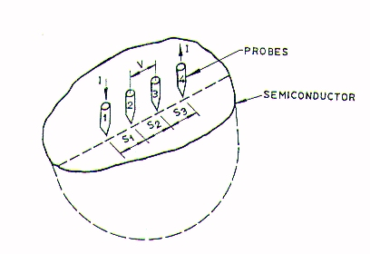

FIG. 5. MODEL FOR THE FOUR PROBE RESISTIVITY MEASUREMENTS.

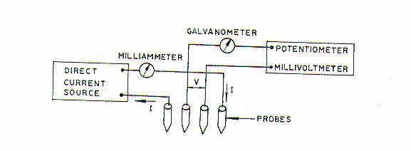

FIG. 6. CIRCUIT USED FOR RESISTIVITY MEASUREMENTS

TABLE I

W/S | G₆ (W/S) | G₇ (W/S)
0.100 | 0.0000019 | 13.863
0.141 | 0.00018 | 9.704
0.200 | 0.00342 | 6.931
0.250 | 0.0182 | 5.865
0.330 | 0.0604 | 4.159
0.500 | 0.228 | 2.780
1.000 | 0.683 | 1.504
1.414 | 0.848 | 1.223
2.000 | 0.933 | 1.094
3.333 | 0.9838 | 1.0228
5.000 | 0.9948 | 1.0070
10.000 | 0.9993 | 1.00045

W: sample thickness, S: Probe spacing

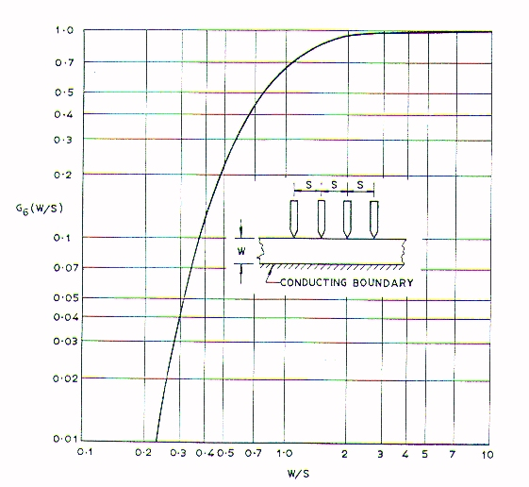

FIG. 8. CORRECTION DIVISOR FOR PROBES ON A SLICE WITH A CONDUCTING BOTTOM SURFACE.

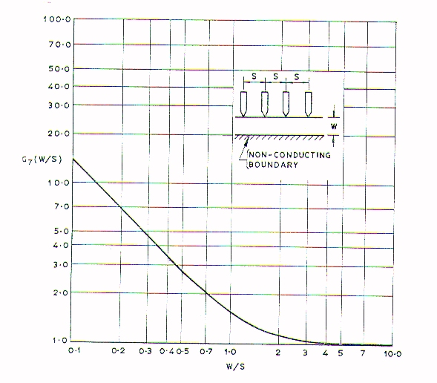
FIG. 9. CORRECTION DIVISOR FOR PROBES ON A THIN SLICE WITH A NONCONDUCTING BOTTOM SURFACE

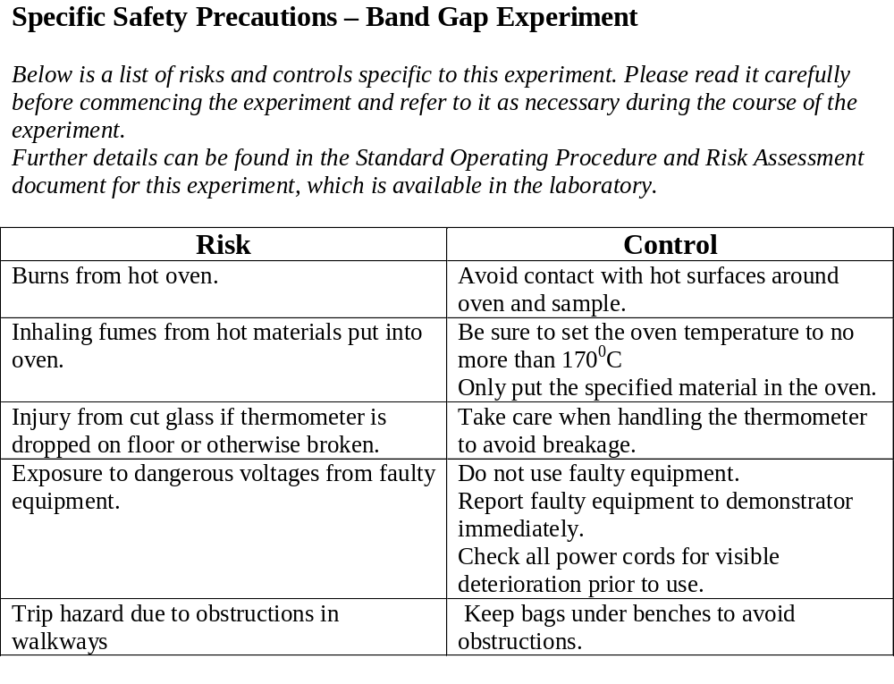

William Lawrence Bragg was awarded the Physics Nobel Prize jointly with his father William Henry Bragg in 1915. W.H.Bragg was born in Australia.

